Project Design Phase-**||**

**Technical Architecture**

**--------------------------------------------------------------------------------------------**

|  |  |
| --- | --- |
| NAME | T.SURESH KUMAR |
| NM ID | EA32343CFBC1AD09D4E465F983490A2F |
| PROJECT | HOW TO CREATE A GOOGLE ADS COMPAIGN FOR YOUR BRAND |

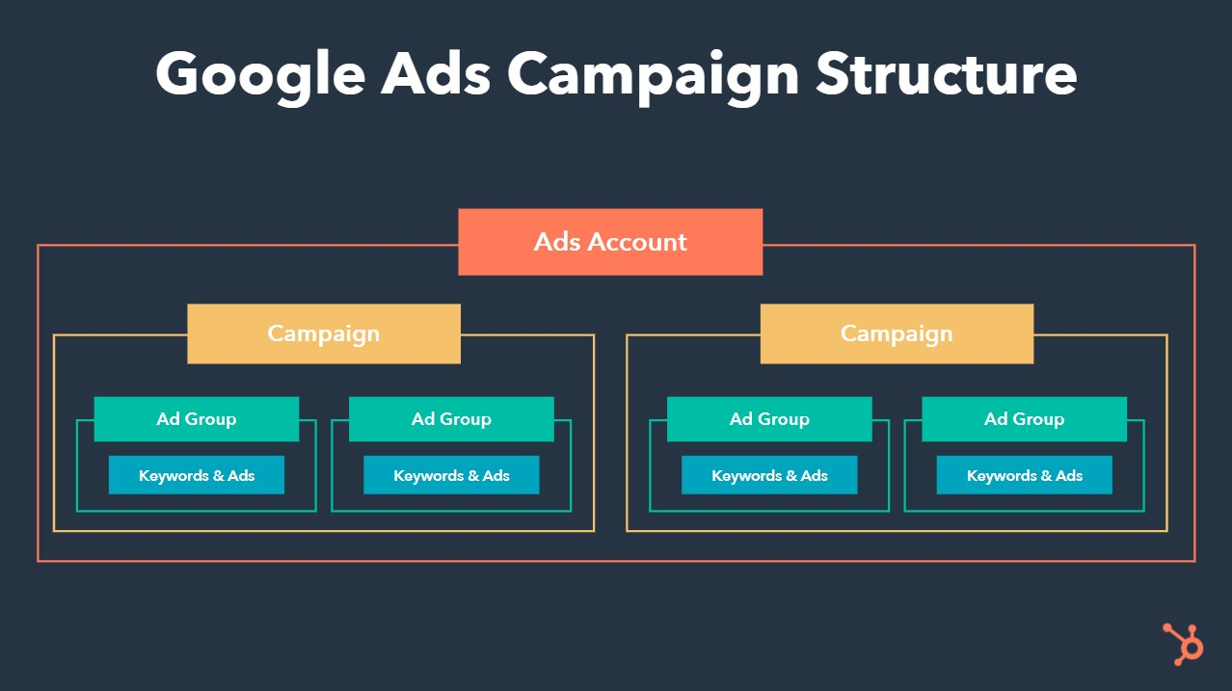.

**1. User Interface (UI):**

- The campaign management starts with a user-friendly interface where advertisers can interact with the system. This can be a web-based application or a mobile app.

**2. Authentication and Authorization:**

- Users need to authenticate themselves to access the system. Implement secure authentication methods, such as OAuth, to ensure the security of user accounts.

**3. Campaign Setup:**

- This is where advertisers define the campaign parameters, including budget, targeting, ad groups, and bidding strategies.

**4. API Integration:**

- Integrate with the Google Ads API to interact with the Google Ads platform programmatically. The API handles various tasks like creating and managing campaigns, ad groups, ads, keywords, and reporting.

**5. Campaign Management Engine:**

- This is the core of the system. It processes campaign setup and management requests, validates inputs, and communicates with the Google Ads API for actual campaign actions.

**6. Database:**

- Store essential data like campaign settings, user profiles, and performance metrics. This data is used for reporting, analysis, and optimization.

**7. Reporting and Analytics:**

- Generate reports based on campaign performance, including click-through rates, conversion rates, and ROI. Use analytics tools to gain insights and make data-driven decisions.

**8. Budget Management:**

- Monitor and manage campaign budgets. Ensure that spending stays within the allocated budget and implement rules for pausing or adjusting campaigns when necessary.

**9. **Keyword Research and Optimization**:**

- Integrate keyword research tools to identify relevant keywords and optimize your keyword strategy for better ad targeting.

**10. Ad Creatives and Landing Pages:**

- Manage ad creatives and landing pages, tracking their performance and making adjustments as needed.

**11. Bidding Strategy:**

- Implement algorithms or rules to adjust bidding strategies automatically, optimizing for clicks, conversions, or other KPIs.

**12. Error Handling and Logging:**

- Implement robust error handling to catch and handle exceptions. Maintain logs to track system activities and errors for debugging and audit purposes.

**13. Security Measures:**

- Ensure the security of user data, API tokens, and system components. Implement encryption, access controls, and regular security audits.

**14. Scalability and Load Balancing:**

- Design the architecture to scale horizontally and distribute the load to handle a large number of campaigns and users efficiently.

**15. Third-Party Integrations:**

- Integrate with third-party tools or services for additional functionality, such as CRM systems, email marketing, or social media advertising platforms.

**16. Quality Assurance and Testing:**

- Regularly test the system for functionality, performance, and security. Implement automated testing to catch issues early in the development process.

**17. Deployment and Monitoring:**

- Deploy the system to a reliable hosting environment and monitor its performance. Set up alerts for critical issues.

**18. Compliance and Policy Adherence:**

- Ensure that the system complies with Google Ads policies and best practices to avoid policy violations that could lead to account suspension.

**19. User Support and Help Center:**

- Provide user support channels, such as chat, email, or a help center, to assist users with questions or issues related to campaign management.

**20. Continuous Improvement:**

- Implement processes for continuous improvement and optimization based on user feedback and evolving advertising trends.